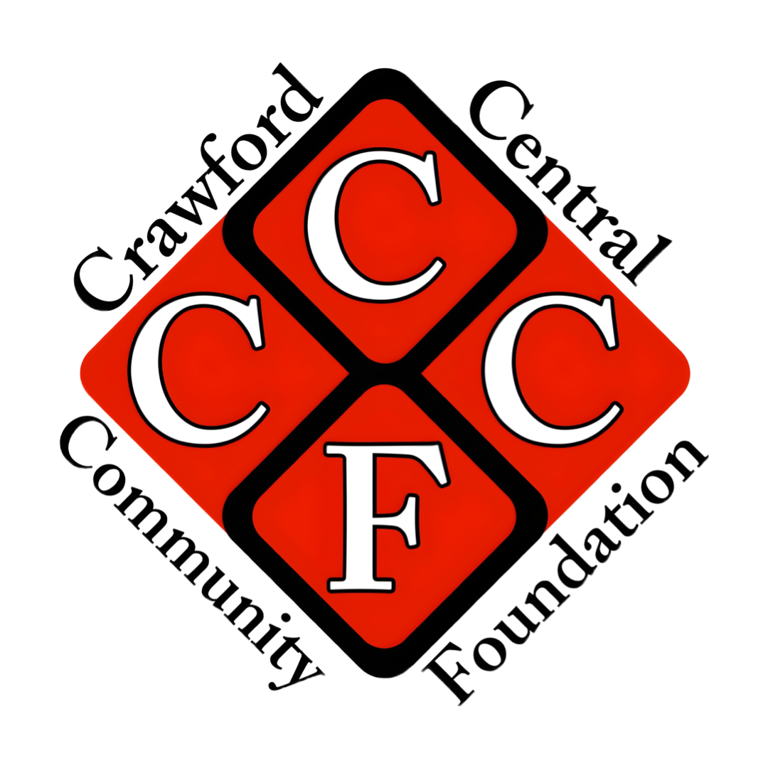

Guidelines for Requests for Funding from the

Crawford Central Community Foundation

What do CCCF grants support?

The CCCF is all inclusive in its support of students, teachers, coaches and advisors, school parent groups, administrators, etc. that seek to enhance or develop academic, athletic, and artistic programs for Cochranton and Meadville public school students in grades K-12.

The CCCF has two central criteria in choosing to support projects: (1) they must provide opportunity and/or experience to K-12 students in the Cochranton and Meadville public schools, and (2) There must be a Pay It Forward project to be completed by those who benefit from the grant.

The CCCF offers 2 funding lines: the Project Fund (for general projects, equipment, and expenses that enhance students’ academic, athletic, artistic and wellness experiences)and the Emergency Fund (for unforeseen, time-sensitive projects and events or for economic hardship of individual students at the coach’s or advisor’s discretion)
For Project Funding, Applications are considered in the Fall (October), Mid-Winter(January) and Spring( March) and must be postmarked by the 15th of the month.
For Emergency Funding, Applications are considered at any time, however the grant writer must justify the Emergency and rationale for not applying for Project Funding during the 3 cycle opportunities during the school year.

The CCCF is strongly committed to the ideal of “Paying it Forward.” Therefore, EACH application (Project or Emergency) must contain a plan to complete a community service project. We believe that giving back to our communities is something we’re all called to do. We want to encourage the students of our schools, as well—to “Pay Forward” through their actions a sense of what they’ve received and what they can offer others. We hope, through the financial support of the CCCF and the “pay it forward” model, to further develop the strong bonds of our community and send the spirit of giving into the future. We encourage the students of the Crawford Central School District to look outward for unique opportunities to serve the community through their Pay-It-Forward. Please see the attached “Exhibit A” for some ideas of community non-profits that would greatly benefit from a Pay-It-Forward initiative by students impacted by this grant.

Who decides whether a project gets funded?

The independent Board of the CCCF carefully considers each funding application and is the sole determiner of which applications receive funding. The Board may choose to offer partial funding at its discretion. Please note: all necessary school district approvals must be obtained separately and are the responsibility of the project director or school advisor/coach. Every effort will be made to review proposals within 30 days of receipt.

What makes a grant application successful?

- The application should be completed in a thorough and thoughtful manner, with clear descriptions of the goals of the projects and materials for which funding is sought. It must include all necessary authorized signatures.

- The proposal should clearly describe the benefit to Cochranton and/or Meadville students of the project or materials for which funding is sought.

- The proposal may be a collaborative effort between educators, schools, organizations, or others to reach children in multiple classrooms, grade levels or buildings. Projects may also be a collaborative effort between different funding organizations (i.e., the PTO or Booster organizations).

- The applicants agree to account for and report on the project once funded. Successful grant recipients will receive a Final Report Form with notification of approval of their grant, and will be asked to attach necessary receipts, a narrative of the project, and the “Pay it Forward” component of their project.

- Grants awarded are limited to $1,200.00

- The proposal should not seek repeat funding for a previously approved project or retroactive funding for an existing project or purchases that have already been made. The Foundation does not work on a reimbursement basis.

- The proposed budget should include any shipping costs.

What types of projects is the CCCF likely to fund? Given the CCCF’s twin goals of providing opportunity and experience to K-12 students in Cochranton and Meadville public schools, we offer the following examples:

Types of Projects We Will Consider Funding:
  - Registration and ticketing for field trips
  - Purchases of library books
  - On-site cultural, artistic or academic events

Types of Projects We Won’t Fund:
  - Transportation. Due to limitations of our insurance, we cannot fund transportation.
  - Maintenance of existing equipment
  - Personal items that would remain in the possession of the students or staff member.
  - Items that are personalized with student names.

