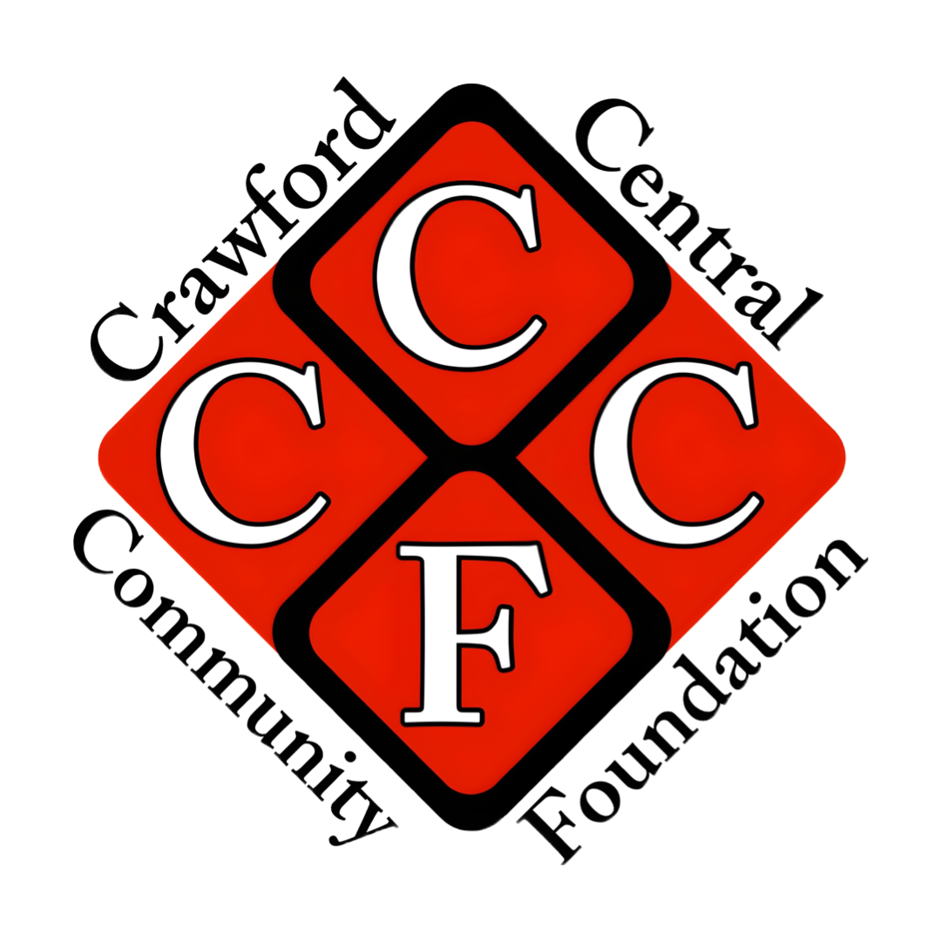
Updated 9/4/2026
CCCF
Grant Application
2026 - 2027
Title of Proposed Project:
Primary Contact Person:
Preferred Email Address:
Cell Phone #:
Position/ Title:
School or Organization Affiliation:
School or Organization Mailing Address:
By signing below, we confirm that we have read the attached guidelines for grant submission and approval and we agree to abide by the established terms.
Signature(s)________________________________________________________ Date__________
Proposals should be typed and submitted to: Crawford Central Community Foundation, PO Box 902, Meadville, PA, 16335. The CCCF reserves the right to partially fund projects, depending on available resources. Proposals may also be scanned and emailed to crawcentfound15@gmail.com A “Request To Apply for a Grant Award” must also be completed from the Crawford Central School District.The form may be found on the school district’s intranet site (www.craw.org) or via this LINK:https://drive.google.com/file/d/1-Xzv2-uLlON_3_ToXi3cSrvkKZhAyAdR/view?usp=sharing
Please respond to the questions below. Requests for field trips require signature approval by the District Administrator. (Please refer to sections 6 and 7 regarding signatures needed)

1. To which funding line are you submitting your request? Please circle below.
The Project Fund The Emergency Fund
Please indicate by circling below the application deadline you are applying to. Applications must be postmarked by the submission deadline. Every effort will be made to review grant proposal applications within 30 days of receipt.
Thursday, October 15 (Fall) Friday, January 15 (Mid-Winter) Monday, March 15 (Spring)
EMERGENCY FUND - Why do YOU consider this funding request an EMERGENCY? What prevented you from applying during our 3 funding cycle opportunities? (Refer to the Grant Guidelines).

2. Describe the project or materials for which you are seeking funding. Reminder to please refer to the Grant Guidelines before completing the application. There must be a “Pay it Forward” component to your project.
A. Project Description:

☐ - Is your PIF Unique? ☐ - Are all of the impacted students involved with the PIF? ☐ - Does your PIF benefit the school and/or community at large?
B. Pay-It-Forward (PIF) Description: ( If you need assistance in choosing a “Pay It Forward” idea, refer to Exhibit A and read the Guidelines).

3. How will this grant impact the school community or community at large?

4. Timeline –
A. If your funding request is approved, when will purchases be made?
B. When will the grant project begin?
C. When will the Pay-It-Forward be delivered and/or presented?
D. When is the grant project projected to be delivered/presented/completed? (For ongoing projects, please state projected time frames)
5. What is the amount of funding you are seeking (Max. CCCF Grant is $1,200) - $ Use the Sources and Uses Table below to provide a detailed budget for the project or materials. Please include all sources of funds and uses of funds in this chart.
Within 6 months of grant approval, the following must be completed:
● Grant Project must be completed and documented
● Pay-it-Forward must be completed and documented
● Invoices for payment must be received by the board for approval
If projects cannot meet the 6-month deadline after being awarded please contact crawcentfound15@gmail.com Please include the name and address to whom payment should be made:
NAME:
ADDRESS:
Please list all uses of funds for your request, including all items to be purchased as well as sales tax, shipping charges, etc.
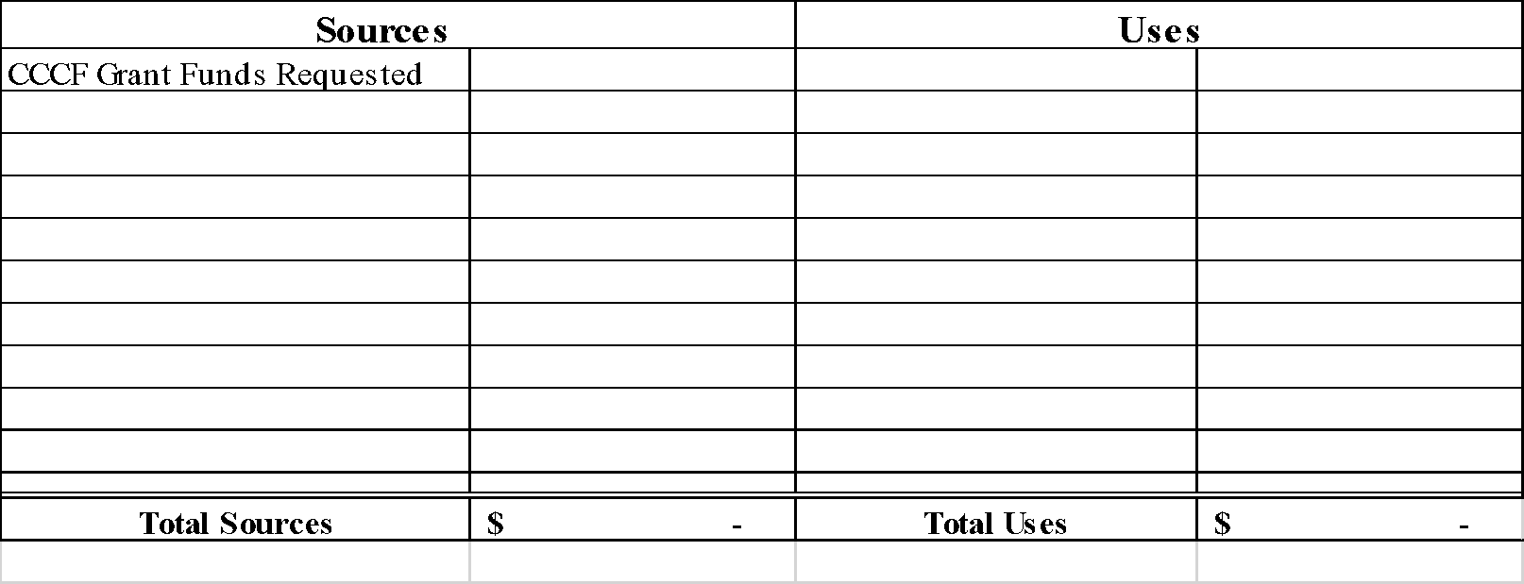

Here is an example of a Sources & Uses table where the total project costs exceed the $1,200 maximum grant:

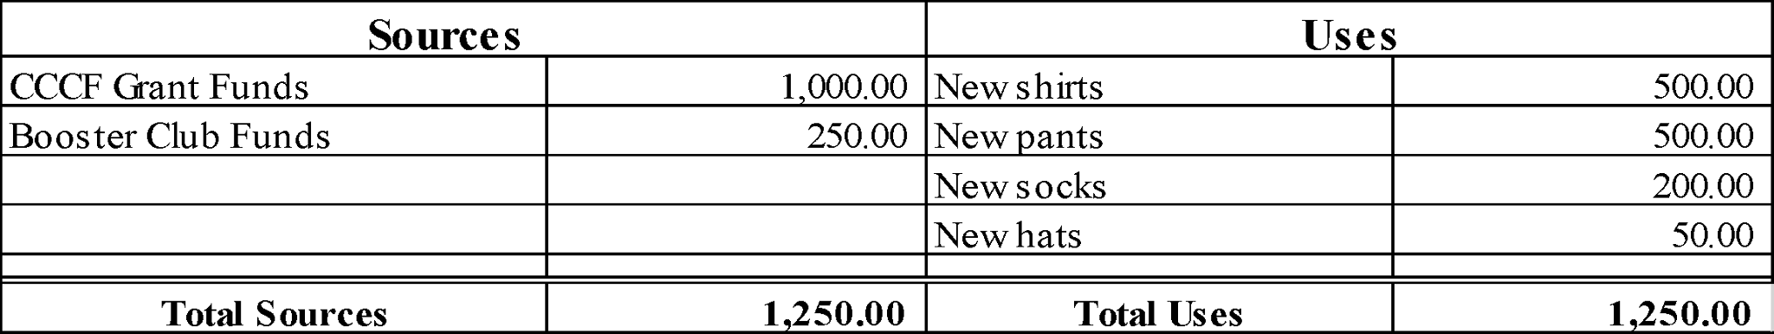

Here is an example of a Sources & Uses table where the total project costs are less that the $1,200 maximum grant:

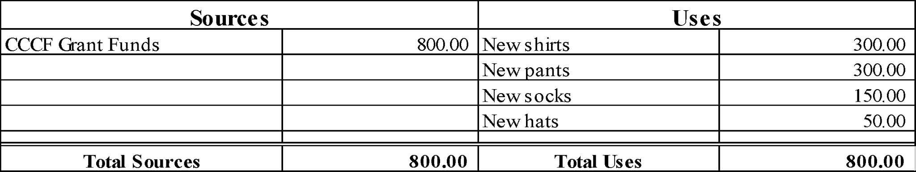
The total sources must equal the total uses.

6. For all grant requests: The signature below indicates that you have submitted your request to the appropriate office of the Crawford Central School District and have received their approval to proceed with your funding request. It is YOUR responsibility to complete and obtain the signatures needed for the CCSD “Request To Apply for a Grant Award” in advance of submitting the Crawford Central Community Foundation’s Grant Application. We cannot move your application forward without this signature as well as the “Request To Apply for a Grant Award” found on the school district’s intranet site (www.craw.org).

Building Principal Signature: Date: __________
7. Field Trip Requests- Please attach a copy with required signatures of the Crawford Central School District Field Trip Form, “Request for Permission to Attend Conference/Visitation Day”. The Crawford Central Community Foundation will NOT cover transportation services.

